**Epic Innovators Ltd.

Patrick M.

Adam W.

Patrick J.

Jay. H

Jacob. K

# Project Description

# Topic

# Motivation

## Landscape

Our app *Insight* brings together systems found in education apps, mindfulness apps, and youth support apps. The Education App space focuses mostly on organising, practicing, and collaborating (Tobin, 2018) (Stenger, 2015) (Cozma, 2014). Apps include *Duolingo,* *Classtree,* and *Kahoot!* (Duolingo, 2020) (Classtree, 2020) (Kahoot!, 2020).Mindfulness focuses on the individual during the free time. These include *Headspace*, *Mood Meter*, and *Grok* (Headspace, 2020) (Hopelab, 2020) (The Project Factory, 2020). Youth Support apps are there for children in crisis seeking help (Kids Help Line, 2020). There are anonymous reporting apps for bullying and self-check wellness apps aimed at young adults (University of Queensland, 2020) (Bullying No Way!, 2020) (Education Queensland, 2020) (NSW Department of Education, 2020). Though there are similarities in concept between all these categories, the focus on the classroom, generalisation of our users, and the execution with schools make *Insight* stand out. It is the only app that focuses on children responding to a series of questions about their mood and what is happening in their lives. Currently, this is done only with special needs students using physical print-out methods. Their responses are rarely logged, failing students’ potential needs. By implementing this broadly across a classroom, educators and admin can better support their whole class. In 2016 *The Mood Check App* attempted this with university students (CTV Atlantic, 2016). This app did not last likely because university students are not made to take time out and report on their emotions, unlike the primary and high school students Insight focuses on. Insights implementation during rollcall makes its introduction to a school less jarring and overtime will help students reflect on their feeling and grow their Emotional Intelligence (EQ) (Busch & Oakley, 2017) (Bariso, 2018). The closet app that could currently compete with ours is *Forum* in Google’s *Education Suite* (Google, 2020). But with many countries either outright banning Google services or severely restricting its use within schools, including Australia, because of privacy and security concerns. (Siegler, 2010) (Education Queensland, 2020) (NSW Department of Education, 2020). These restrictions alongside our curated questions and data analytics separate us from what Google’s Forum can. Through this analysis, we can see *Insight* is well positioned for success with no direct competition.

# Detailed Description

## Aims

The fundamental objective of *Insight* is the development of a survey platform to provide schools with the means for ongoing visibility into the wellbeing and engagement of their students. The survey is to be delivered via a mobile app that runs on students’ BYOD smartphones and tablets, with an intuitive interface relatable to the younger generation. The results of the survey are to be visible to the teacher/home room mentor for each year/class in real-time, for prompt insight into their students. The school headmaster, deputy, or delegated administrator would have the ability to view survey results across the school for a higher overview of students’ health as well as trends over periods of time.

### Project Goals and Priorities:

Primary - required for achieving the basic functionality to achieve the aim:

1. The development of a simple survey interface using intuitive ‘emoji’ icons, as these are relatable particularly to the younger generation and widely used for emotional expression on social media. The survey interface, including icon designs and survey questions, is to be designed in consultation with psychologists to ensure the students respond honestly and accurately, for example if the icons are humorous the survey may not be taken seriously which will negate the exercise. Privacy and anonymity of responses is paramount, and there is to be no possibility of an individual student’s responses being traced back to the student.
2. The ability for survey results are to appear graphically on the teacher’s tablet device, and update in real-time as students submit their responses. This will enable the teacher to receive feedback from students promptly and intuitively through an easy to comprehend format. It will also enable the teacher to promptly close the survey once all students have submitted their responses. Similarly, the school administrator will receive real-time aggregated results from the all students across the school.
3. As the survey will be completed via students’ BYOD devices, the ability to connect new devices to the class/school efficiently is key to the success of the product. The use of QR codes is useful for this purpose, where a class of students can simply download the app and scan the teacher’s tablet to join the class, and start receiving surveys which are then associated with the teacher and school. There should be no requirement for students to sign-up, create logins and such, which would be laborious and potentially create privacy concerns.
4. The establishment of a central cloud-hosted database where all survey results can be collected, analysed, and reported. Initially the collected data will be used internally by Insight for measuring success of the project and developing reports, which can then be delivered to school administrators through updated app functionality. The cloud-hosted model will minimise capital costs, provide the database a robust connection to the Internet, and flexibility to upscale the over time.
5. The success of the project is based on potential uptake of the service by schools. As there will be significant capital investment in development and setup of the back-end infrastructure, the highest priority is to determine the potential market adoption of the service. While based on preliminary observation it appears such apps are currently not in use/existence, it is critical to understand how well the market will receive and adopt a service of this nature once it becomes available. This will require some relationship building with people in the target industry, and research through trusted channels that may also be willing to participate in trials and piloting of the system.

Secondary – nonessential in the initial release however valuable to make available in the near term:

1. The ability for the school administrators to receive summarised statistics from other schools within the same region and country for the purpose of benchmarking survey results. This would provide valuable information in understanding and identifying emerging trends and patterns and coordinating local and broader initiatives with other schools to address growing areas of concern.
2. The ability for teachers to append a general comment against the results of each survey. There are events that can cause distress and anxiety across a school, from stressful exam periods to the passing of a fellow student or teacher. These events will likely reflect in the survey responses and would be valuable for teachers to note against surveys data recorded during those periods.
3. ‘Tip of the Day’ displayed to students via the app at the end of the survey. The end of the survey provides an opportunity to communicate with students some brief and basic information on dealing with common problems, or problems they may be facing that they have expressed via the survey such as anxiety, sadness, and bullying. It can also be an encouraging statement of the day. These tips can be prepared by specialist psychologists to optimise their effectiveness in communication.

Tertiary – to be progressively incorporated over the longer-term roadmap:

1. The ability for school administrators to log in to Insight via the web, to access reports and information using a PC and browser. The website would have the same functionality as accessing via a mobile/tablet device and would provide school administrators the option to use the system via tablet or online based on their preference. This will also enable multiple administration staff to access information online.
2. The ability for school administrators to select which survey questions to present their students from a pre-defined list developed in consultation with psychologists. The ability to create customised questions is also a possibility, however, may lead to complications if administrators fail to give due thought and consideration to the questions they create. This in turn may create public controversy and harm the Insight brand.
3. Development of the app interface and survey questions in various languages for potential deployment in a variety of countries and regions. This would ensure the highest chance of comprehension and yield the highest accuracy in responses. Expand the reach and markets of the product would also provide further return on investment.
4. The ability for survey results to be analysed using AI technology, where emerging trends and psychological patterns can be identified and flagged across one or more schools and regions. The ability to decipher legitimate survey responses from illegitimate based on consistency of responses, and combinations of responses from individual students.
5. An S.O.S feature enabling a student in distress to discretely identify themselves to the school and reach out for help. This feature, while beneficial, would need to be considered carefully to avoid compromising the committed privacy/anonymity assurances of the platform.

## Plans & Progress

## Communication Architecture:

### Initial Concept:

* Student devices communicate directly with the Teacher’s device to receive the survey and transmit results via short range device-to-device technology, such as Bluetooth, NFC or across Wireless LAN.
* Teacher’s device communicates with school Administrator’s device via a similar device-to-device technology, such as Bluetooth, NFC or across Wireless LAN - (Bluetooth/NFC would need to be done during class breaks in, e.g. staff lunchroom)
* School Administrator’s device transmits data to the cloud hosted database via LAN to Internet.
* All data communication is encrypted.

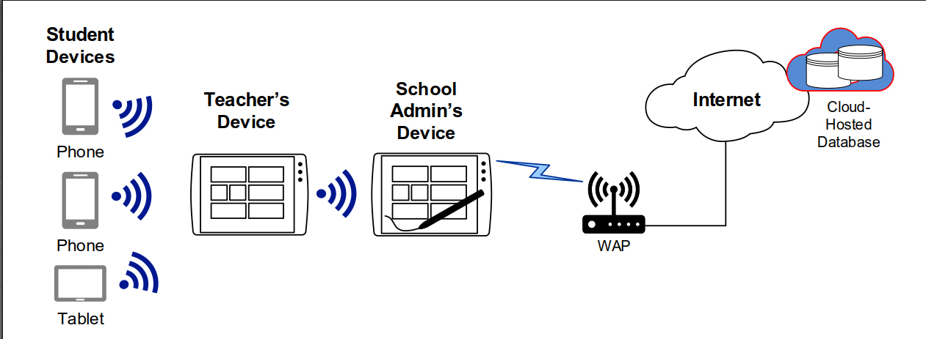

The idea behind this concept is to ensure absolute privacy and anonymity of individual students by having no communication of survey results from any single device directly to the internet/cloud, but only aggregated data from the school Administrator’s device.

Upon analysis of this initial concept the following limitations were identified:

1. For Student to Teacher device communication, Bluetooth is unable to transfer data without specific pairing with each student device, which is complex and time consuming to perform. Furthermore, most smartphones and tablets are limited to only a few Bluetooth devices connected at the same time.
2. NFC can transfer data without pairing, however the device proximity is logistically prohibitive, as each student would need to tap their device to the teacher’s at very close range for each data transfer. Furthermore, there are some smartphones and tablets that are lacking NFC capability.
3. Wireless LAN may be possible, however is challenging and complex to develop, would require more functionality in the application. The teacher’s device would potentially need to be configured as a Hotspot for other devices to join and upload data, then requiring the teacher to turn on/off Hotspot (tethering) each day to receive responses. This would also create delays for students in disconnecting from their current Wi-Fi connections and joining the teacher’s hotspot to complete the survey.
4. The recent Coronavirus pandemic has also challenged this architecture, with students working from home, the above-mentioned communication technologies would be ineffective and students would be unable to complete the survey while operating remotely.

### Revised Concept:

* All devices communicate directly with the cloud database via LAN to Internet.
* All data communication is encrypted.

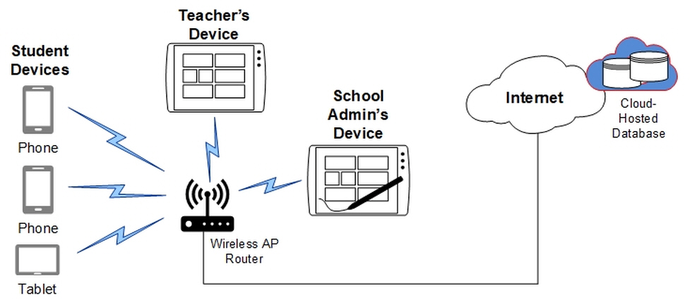

This concept is considerably simpler and overcomes all previous limitations in earlier concepts. The student devices can complete the survey from home or anywhere provided they have an internet connection. Teacher and Administrator devices can similarly view results from any location.

This concept requires significant refinement in security to avoid any risk of individual survey results being intercepted, captured, or traced back to an individual student. Furthermore, as the database will now record individual survey responses from every student (as opposed to only aggregated data for each class from the Administrator’s device), increased security measures are required to ensure individual student responses are unable to be queried or retrieved over the internet under any circumstances.

## Application Functionality:

### User Setup & Device Linking Process:

#### Initial Concept:

* The Administrator’s client app on first-time use prompts the user to select the following information:
* **Country** (Mandatory) – drop-down list of defined countries
* **Region** (Mandatory) – drop-down list of defined states/provinces

These fields are the minimum required for the purpose of data analysis, reporting, and providing basic benchmarking feedback to schools. Once this initial information is entered into the Administrator’s client app, the data is sent to the database where it registers as a new ‘Deployment’ (a single school may run multiple instances). The database will assign a new “Unique ID” for the deployment, which will be sent back to the Administrator’s client app, creating the permanent reference link between the deployment and the database instance for that deployment.

* The Teacher’s client app on first-time use prompts the user to select the following information:
* **Year/Form** (Mandatory) – drop-down list of defined values - e.g. K1 to 12
* **Description** (Optional – 20 characters max.)– free text field to enter a class description - i.e. to differentiate potentially multiple classes within the same year/form.
* The Teacher is then prompted to link their device with the Administrator’s device.

These fields are the minimum required for the purpose of differentiating classes. Once this information is entered into the Teacher’s client app, the data is sent to the database where it is validated to ensure the Year/Form and Description combined are unique, after which it registers as a new ‘Teacher’. The database will assign a new “Teacher ID” for the class, which will be sent back to the Teacher’s client app, creating the link between the Teacher and Administrator.

* The Student’s client app on first-time use prompts the user to link their device with a Teacher’s device.

Device Linking Process:

* Once the app is registered on the Administrator’s device, Teachers’ devices can start to be linked.
* The Administrator selects a function to put the device into “Linking Mode”, where the app will generate a QR code and display it on the screen. The QR code represents the Unique ID of the deployment (UNID_Deploy), which remains constant for the particular deployment.
* Teachers also install the app and, after initial setup, select a function to put their device into “Linking Mode”. The camera is then activated on their device, and by scanning the QR code displayed on the Administrator’s device, the devices are linked. Through this process the Teacher’s device inherits and stores the UNID_Deploy. A Teacher’s device can only be linked to one Administrator’s device at any time.
* Students similarly install the app and on first-time use the device goes directly into “Linking Mode”. The camera is activated on their device and by scanning the QR code of the Teacher’s device (which is also placed into Linking Mode), the two devices are linked. Through this process the Student’s device inherits and stores the UNID_Deploy, and also a Unique ID generated by the Teacher’s device (UNID_Teacher). A Student’s device can only be linked to one Teacher’s device at any time.
* Once linking is complete, when students submit survey responses, the information sent to the database is tagged with both the UNID_Deploy and UNID_Teacher.

Upon analysis of this initial concept the following limitations were identified:

1. The model fails to cater for the scenario where the Administrator’s device or Teacher’s device are factory reset or replaced with another device (if lost/stolen/damaged) and the application needs to be re-installed for any reason. For example, with the above concept, re-installation of the application on the Administrator’s device will register a new deployment and require re-linking of all Teacher and Student devices. More notably, the relationship with all the historical survey data would be lost. The concept therefore requires a mechanism for a new installation of the app to preserve links to an existing database and other devices.
2. The model lacks a work-around where a device has a non-functioning camera, or that may be located remotely, and unable to scan the QR code for linking.
3. A malicious user with a leaked photo/image of a school’s QR code can potentially download the app and scan the image, to link an illegitimate device to that school’s surveys.
4. If/when a student leaves a school they will continue to receive and respond to surveys from their device.
5. The model has three-too-many apps on the Play/App Store for the one application. Rather than three separate apps for Admin/Teacher/Student, it would be better to combine these.

#### Revised Concept:

1. The solution to overcome the limitations with re-installation of the app is to require the school Administrator to create a log in account, which then stores the deployment configuration information. The Administrator’s client app on first-time use will prompt the user with options “Sign-up” or “Sign-in”. The Sign-up path will prompt the user to nominate an Email Address and Password along with the other fields during initial setup. Standard security process will also be required as part of this account registration, including a verification email sent to the nominated email address.

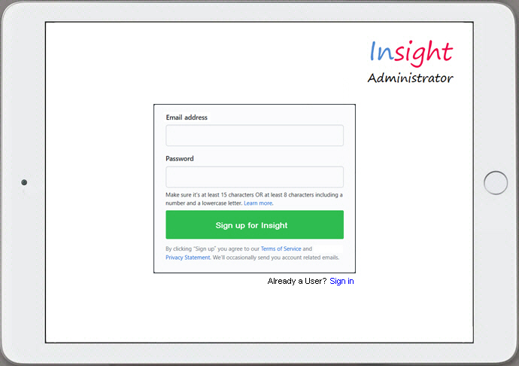

The added benefit of this sign-in feature is the ability to have more than one Administrator device.

A Teacher’s device similarly needs the ability to have the app re-installed with previous links preserved. However, this should be achievable without the need for Teachers to also create a log in account, which is preferable to avoid. Restoration of configuration can be achieved at the time of linking the Teacher’s device with the school Administrator, where the Administrator can select ‘New Teacher’ or ‘Existing Teacher’ when in Linking Mode. The Existing Teacher option will retrieve a list of Teacher ID’s from the database which the Administrator can select from to present the QR code for scanning; effectively giving the Teacher’s device back its original UNID_Deploy and UNID_Teacher.

1. To address the issue of linking where a device has a non-functioning camera or is located remotely, an alphanumeric code (representing the UNID) can be displayed under the QR code for the linking user to manually enter their device. This also provides the flexibility to send the code via messaging to a remote person to link up their device.

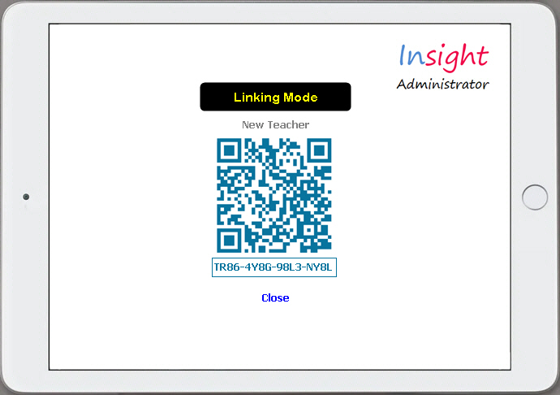

This may be addressed by moving from QR code linking to possibly NFC, where codes are not visible, however NFC presents its own limitation as covered under Communication Architecture.

1. To prevent a malicious user with a leaked photo/image of a school’s QR code from linking an illegitimate device to the school is a challenging obstacle. One method is to have an acknowledgement process, such that when a Student scans a Teacher’s device, the Teacher’s device has a pop-up to ‘Approve/Reject’ the link request. This would also apply for when a Teacher’s device is linking to an Administrator’s device. The process effectively creates a 3-way handshake whereby: 1) the Teacher’s device presents a QR code; 2) Student’s device scans and sends back an approval request; 3) the Teacher must approve the request. This requires additional development and adds some complexity to system, however is a major vulnerability necessary to address (lessons taken from Zoom).
2. A school must incorporate into their student exit checklist to verify that a departing student has uninstalled the app from their device. The same would apply for teachers leaving the school.
3. The number of apps is able to be reduced from three to two by combining the Teacher and Student app. Then only two apps will be on the play store; the ‘Administrator’ and the ‘Student-Teacher’ (similar to Uber where there is a separate Driver and Rider app). The Administrator app will have greater features and functionality and will therefore be of a larger size than the Student-Teacher, this concept keeps the download and footprint smaller for the vast majority of users. This model also nicely accommodates the monetisation concept, covered under the investment section. Once the Student-Teacher app is installed, first-time use will prompt the user to select if they are a Student or Teacher, the setup wizard (as shown in the below diagram) will then progress accordingly. The Approval process described in point 3 will ensure a Student is unable to setup as a Teacher, even if they were to obtain the necessary codes.

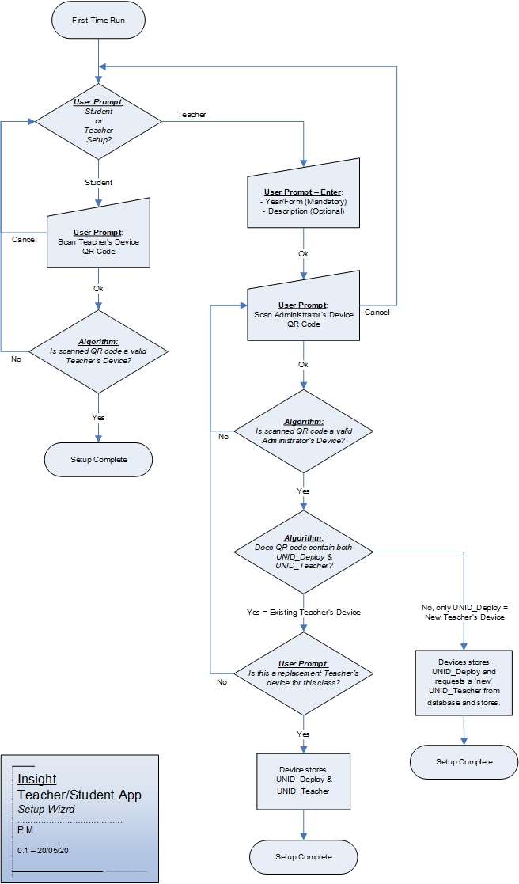

## Survey User Interface:

There are three different groups of users each requiring unique functionality: Students, Teachers and Administrators. The differences in user interface are based around the specific functionality required.

### Teacher Device:

The teacher will launch the Insight app and when ready click ‘Start New Survey’. This will make the day’s survey available on all linked student devices. The time/date information displayed on the home menu screen will allow the teacher to keep the app open while monitoring the time until their desired start time.

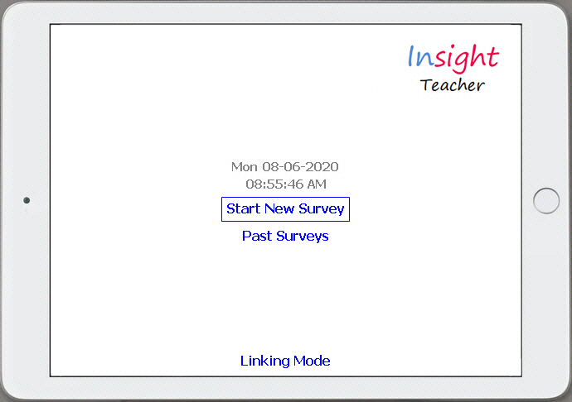

As students complete the survey, the Teacher’s device will update to display the results in real-time.

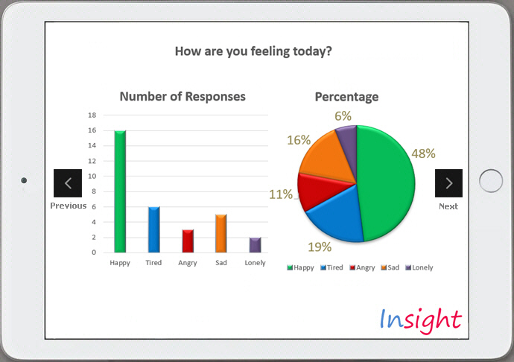

The teacher can swipe left and right through pages to review responses to various survey questions; with the information displayed in an easy to read graphical format.

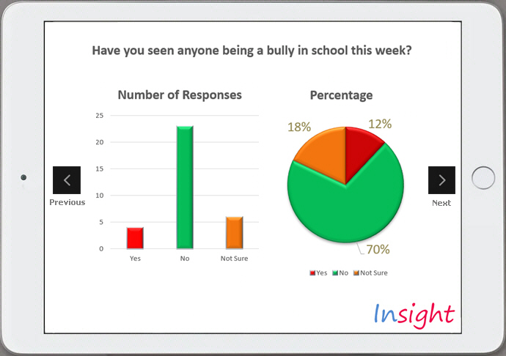

After a few minutes the Teacher can end the survey by clicking ‘Close Survey’ on the far right page; after which no further responses can be submitted by students. A future development would be to include the ability for a teacher to append a short comment to the survey results.

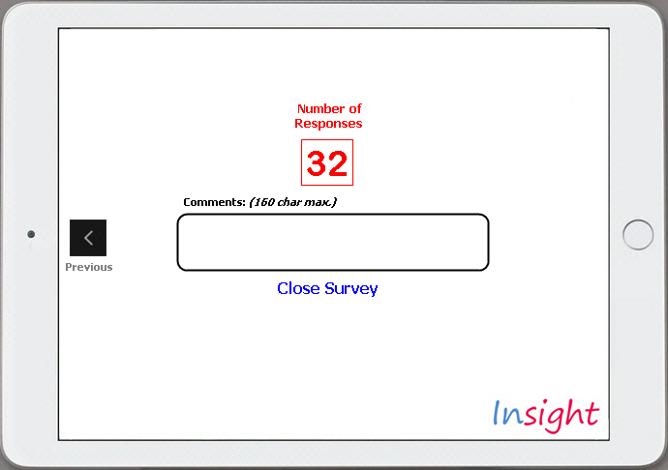

### Student Device:

The Student survey is to be optimised for viewing in portrait as well as landscape mode; whereas the Teacher and Administrator views will primarily be landscape only.

Students will launch the Insight app and once the survey has been started by the teacher, the device will download the latest survey and immediately start prompting the student with questions.

Students will click through the 5-6 questions and respond by selecting intuitive emoji icons. The app functionality will ensure each student is only able to respond once to each survey initiated by a teacher.

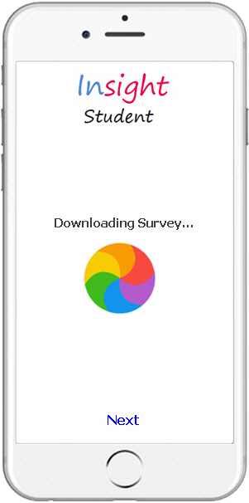 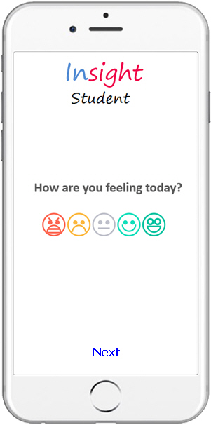 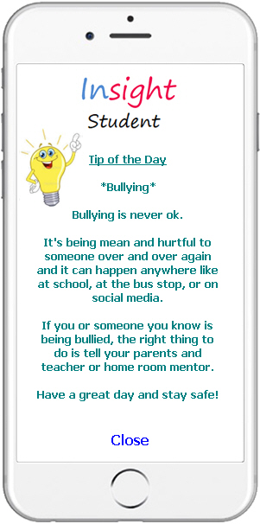

Consultation with specialist psychologists will determine the specific survey questions, and how to analyse the feedback. Specialists will also be heavily involved with design of the emoji icons, as these are key to obtaining accurate responses. These may also vary based on the target demographic, as specified by the teacher in Year/Form field during setup.

A future development is for students to be presented with a ‘Tip of the Day’ at the end of the survey. This can be an encouraging statement or how to deal with a particular difficulty as expressed by the student in the survey.

### Administrator Device:

The Administrator’s app will be a dashboard view very similar to the Teacher’s app in terms of the ability to view survey results of classes, with the added ability to report on aggregated results across the whole school/deployment as well as averages and trends over selected periods of time.

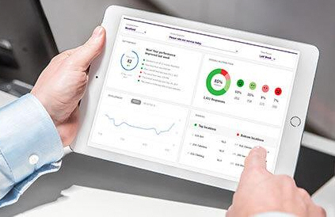

Future developments can include:

* Web browser access for administrators via Insight’s web site, for access to results via PC
* Automated psychological analysis of survey results, that may be determined using AI technology
* Suggested tips and strategies for school administrators to address identified emerging issues.

## Database and Infrastructure:

The database will require significant capacity to handle the potentially thousands of schools, tens-of-thousands of teachers, and hundreds-of-thousands of students that will connect each day. This will require growing storage over time, and significant processing power as majority of connections will occur at around the same time each weekday morning, when students are completing the survey.

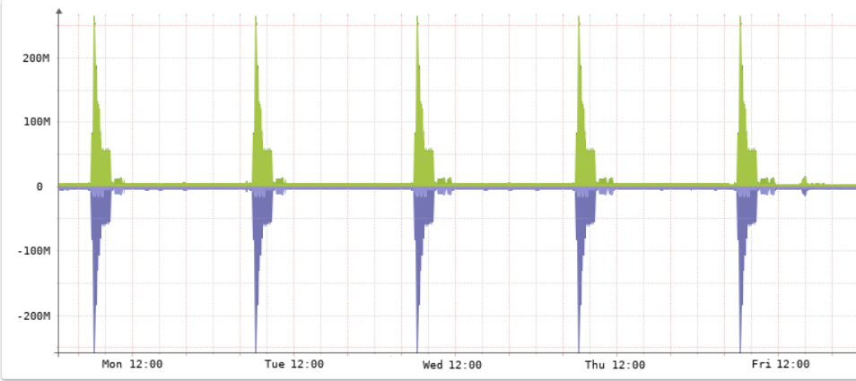

*Hypothetical utilisation during an average week – bandwidth, processing and database I/O.*

The survey database will potentially grow to tens-of-millions of records in three to five years depending on uptake. As an example, a user base of 100,000 students, completing the survey 3 times per week would generate 12 million records per annum (depending on the table design). For historical tracking, there may also need to be lengthy retention periods and archiving process. The database architecture and structure require the engagement of specialist consultants to design.

The concept is to use Platform as a Service (PaaS) for the database hosting, which will minimise capital costs, provide a fast and reliable backbone to the Internet, and the flexibility to initially start small and upscale over time. PaaS would also provide the ability to quickly create additional development and test environments as needed. PaaS providers such as Oracle would be considered as preferred options as they specialise in large-scale databases, with AWS and Azure also evaluated. This component of the project requires considerable due diligence.

There is also infrastructure required for the solution to operate, including firewalls, security, authentication and web servers. These services will similarly be cloud hosted using Infrastructure as a Service (IaaS). Ideally, the same cloud provider would host both the PaaS and IaaS to have all systems in a common data centre, ensuring highest reliability and performance for communication between the database and various other servers in the ecosystem.

Database security and communication between devices and the database is another area that requires careful planning and design. At a high level all communication is to be encrypted between the app and database. Student devices will be limited to ‘write’ only access to the database, while Teacher and Administrator devices will have the ability to also query the particular school’s data; this requiring a strong authentication mechanism to avoid malicious users from emulating the app to gain access via other means.

## Roles

## Scope and Limits [Patrick working on]

## Tools and Tech

## Testing

## Timeline

## Risks

## Group Processes and Communication

# Skills and Jobs

## Job Descriptions

# Group Reflection

## Blurb

# Bibliography

Landscape Bibliography

Bariso, J., 2018. *13 Signs of High Emotional Intelligence.* [Online]   
Available at: https://www.inc.com/justin-bariso/13-things-emotionally-intelligent-people-do.html  
[Accessed 27 April 2020].

Bullying No Way!, 2020. *Apps.* [Online]   
Available at: https://bullyingnoway.gov.au/Resources/BullyingNoWayApps  
[Accessed 27 April 2020].

Busch, B. & Oakley, B., 2017. *Emotional intelligence: why it matters and how to teach it.* [Online]   
Available at: https://www.theguardian.com/teacher-network/2017/nov/03/emotional-intelligence-why-it-matters-and-how-to-teach-it  
[Accessed 27 April 2020].

Classtree, 2020. *Classtree - Parent Teacher Communication App.* [Online]   
Available at: https://www.classtree.co/  
[Accessed 27 April 2020].

Cozma, N., 2014. *8 essential apps for back to school.* [Online]   
Available at: https://www.cnet.com/how-to/essential-apps-for-back-to-school/  
[Accessed 27 April 2020].

CTV Atlantic, 2016. *University students asked to track feelings with Mood Check app.* [Online]   
Available at: https://atlantic.ctvnews.ca/university-students-asked-to-track-feelings-with-mood-check-app-1.2813254  
[Accessed 27 April 2020].

Duolingo, 2020. *Duolingo for Schools.* [Online]   
Available at: https://schools.duolingo.com/  
[Accessed 27 April 2020].

Education Queensland, 2020. *Reporting.* [Online]   
Available at: https://education.qld.gov.au/schools-educators/other-education/home-education/reporting  
[Accessed 27 April 2020].

Education Queensland, 2020. *Student Wellbeing.* [Online]   
Available at: https://education.qld.gov.au/students/student-health-safety-wellbeing/student-wellbeing  
[Accessed 27 April 2020].

Google, 2020. *G Suite for Education.* [Online]   
Available at: https://edu.google.com/products/gsuite-for-education/?modal_active=none  
[Accessed 27 April 2020].

Headspace, 2020. *Meditation and Sleep Made Simple - Headspace.* [Online]   
Available at: https://www.headspace.com/  
[Accessed 27 April 2020].

Hopelab, 2020. *Mood Meter App.* [Online]   
Available at: https://moodmeterapp.com/  
[Accessed 27 April 2020].

Kahoot!, 2020. *Kahoot! for Schools.* [Online]   
Available at: https://kahoot.com/schools/  
[Accessed 27 April 2020].

Kids Help Line, 2020. *Apps.* [Online]   
Available at: https://kidshelpline.com.au/tools/apps  
[Accessed 27 April 2020].

NSW Department of Education, 2020. *Cloud Services Risk.* [Online]   
Available at: https://education.nsw.gov.au/enterprise-risk-management/risk-resources/best-practice/cloud-services-risk  
[Accessed 27 April 2020].

NSW Department of Education, 2020. *Using Apps for Mental Wellbeing.* [Online]   
Available at: https://education.nsw.gov.au/parents-and-carers/wellbeing/articles/using-apps-for-mental-wellbeing  
[Accessed 27 April 2020].

Siegler, M., 2010. *MG Siegler.* [Online]   
Available at: https://techcrunch.com/2010/04/19/google-censorship/  
[Accessed 27 April 2020].

Stenger, M., 2015. *30 Useful Apps For Students You Probably Don’t Know About.* [Online]   
Available at: https://www.opencolleges.edu.au/informed/features/30-of-the-best-productivity-apps-for-online-students/  
[Accessed 27 April 2020].

The Project Factory, 2020. *Grok.* [Online]   
Available at: https://ttlgrok.pmc.gov.au/  
[Accessed 27 April 2020].

Tobin, L., 2018. *Student essentials: apps to make university life easier.* [Online]   
Available at: https://www.theguardian.com/education/2018/dec/17/apps-for-university  
[Accessed 27 April 2020].

University of Queensland, 2020. *Health and Wellbeing.* [Online]   
Available at: https://my.uq.edu.au/information-and-services/student-support/health-wellbeing  
[Accessed 27 April 2020].